Creep Modeling in Abaqus

1. Create a copy of existing model (operating load case) in Abaqus.
2. **Make sure the model stress units are in ksi.**
3. Copy material for which you want to model creep and rename as **SA-376-347H_U**
4. Add **Creep** card under plasticity and select User-defined under “Law” dropdown.
5. Add **User Defined Field** card under General tab.
6. Add **Depvar** card under General tab and change **Number of solution dependent state variables to 9**. Leave Variable number controlling element deletion to 0.
7. Add **Electrical Conductivity** card and change **number of field variables to 3**. **Change values to 1** for all blanks.
8. Save the material and change the material definition in the model.
9. Create a new step at the end using the **Visco** procedure and enter time period in hours. This is the actual time for which you want the model to creep. Two years would be roughly 18000 hours.
10. Under **incrementation** tab, use the values as shown below: 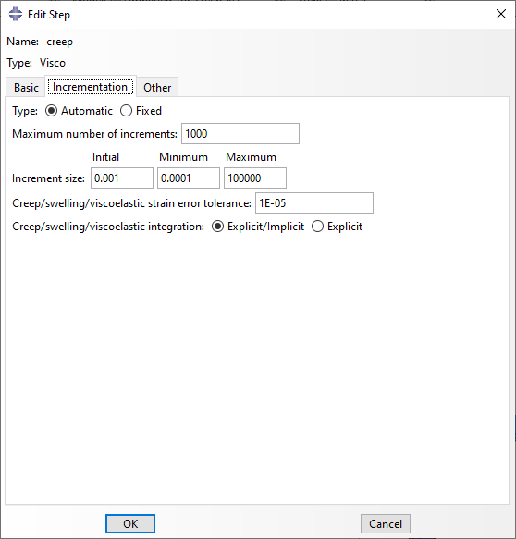
11. The maximum increment size should be the time period you entered under the **basic** tab. Click ok to accept all other values as default.
12. Under **field outputs**, add CE, CEEQ, CEMAG, and SDV.
13. Save the model.
14. In Abaqus odb, see following definitions for state variables:
    * SDV4 - sige (effective stress)
    * SDV5 - min creep damage (WRC541)
    * SDV6 - mean creep damage (WRC541)
    * SDV7 - min creep damage (API 530)
    * SDV8 - avg creep damage (API 530)
    * SDV9 - MPC Omega creep damage
15. Run the model in command line using **user=header_6_sinh.f** flag.